
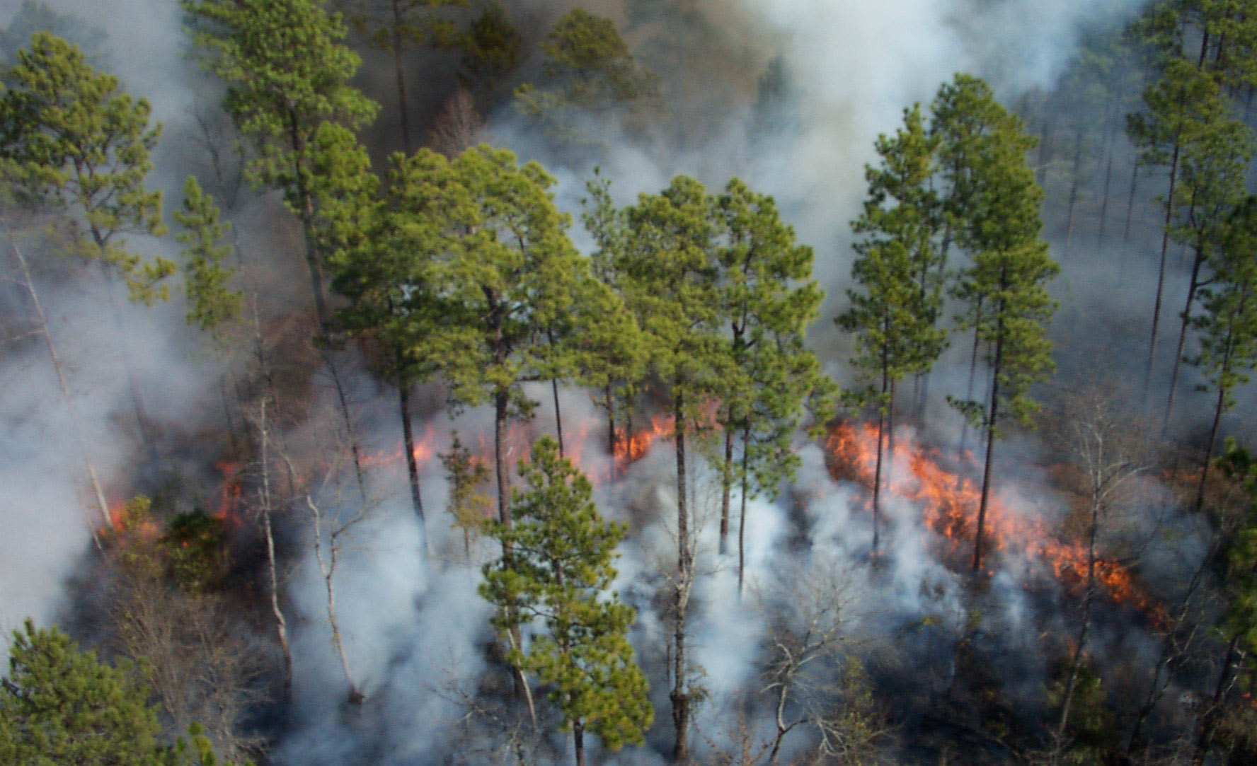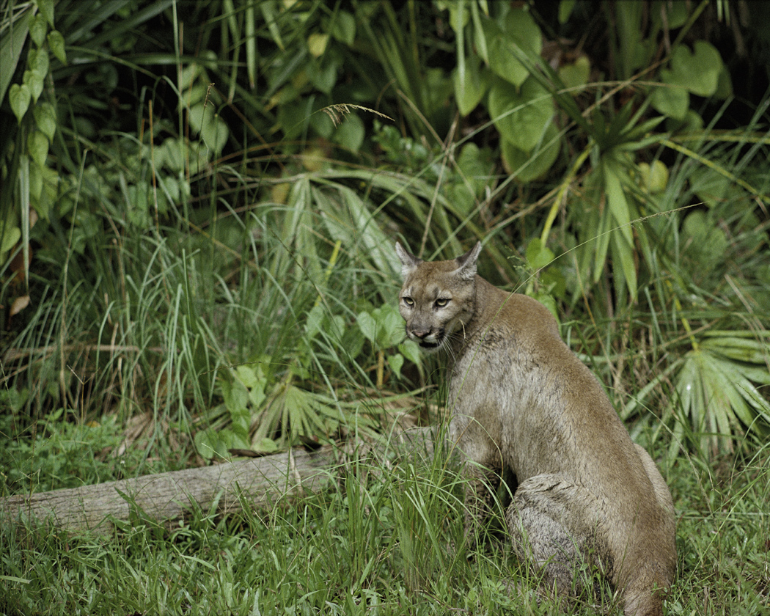

ERAtools Administrator

August 6, 2008
Version 1.4

URS Corporation
1625 Summit Lake Drive, Suite 200
Tallahassee, Florida 32317

Table of Contents
1 Introduction 1-1
2 Application Overview 2-1
2.1 Creating a New Analysis Definition File 2-1
2.2 Editing an Existing Analysis Definition File 2-3
2.3 Saving an Analysis Definition File 2-3
2.4 Menu Items 2-3
3 Analysis Definition File Elements 3-1
3.1 Issues 3-1
3.1.1 Adding Issues 3-1
3.1.2 Adding Additional Issues 3-1
3.2 Spatial Analyses 3-2
3.2.1 Analysis Types 3-2
3.2.1.1 Pinpoint Analysis 3-3
3.2.1.2 Generic Resource Analysis 3-3
3.2.1.3 Weighted Average 3-3
3.2.1.4 Feature Comparison 3-6
3.2.1.5 Distance 3-7
3.2.1.6 Distance and Direction 3-10
3.2.1.7 Comparison Resource 3-11
3.2.2 Specifying Data Source 3-12
3.2.3 Specifying a Definition Query 3-12
3.2.3.1 Field names 3-13
3.2.3.2 Strings 3-14
3.2.3.3 Wildcard Characters 3-14
3.2.3.4 The NULL keyword 3-15
3.2.3.5 Querying Numbers 3-15
3.2.3.6 Calculations 3-15
3.2.3.7 Operator Precedence 3-16
3.2.3.8 Combining Expressions 3-16
3.2.3.9 Querying Dates 3-16
3.2.4 Column Headers 3-16
3.2.5 Grouping and Summarizing Data 3-16
3.2.6 Sorting Data 3-17
3.2.7 Specifying Fields to Display 3-17
3.2.7.1 Summarization Options 3-18
3.2.7.2 Weighted Average Analysis Options 3-18
3.2.7.3 Hyperlinks 3-19
3.3 Related Tables 3-20
3.3.1 Related Tables in Comparison Resource Analysis 3-21
3.4 Workspaces 3-21
3.4.1 SDE Workspaces 3-22
3.4.2 Shapefile Workspaces 3-22
3.4.3 Access Workspaces 3-23
4 Analysis Definition File Validation 4-1

Figures
Figure 2-1: ERAtools Administrator Main Screen 2-1
Figure 2-2: File Menu and Toolbar 2-2
Figure 2-3: Blank Analysis Definition File 2-2
Figure 3-1: Issue Screen 3-1
Figure 3-2: Editing Analysis Layers 3-2
Figure 3-3: Generic Resource Analysis 3-3
Figure 3-4: Weighted Average Analysis 3-5
Figure 3-5: Feature Comparison Analysis (Point or Linear Analysis Features) 3-6
Figure 3-6: Feature Comparison Analysis (Polygon Analysis Features) 3-7
Figure 3-7: Distance Analysis: Point-to-Point 3-7
Figure 3-8: Distance Analysis: Point to Line 3-8
Figure 3-9: Distance Analysis: Point-to-Polygon 3-8
Figure 3-10: Distance Analysis: Line to Point 3-9
Figure 3-11: Distance Analysis: Line to Line 3-9
Figure 3-12: Distance Analysis: Line to Polygon 3-9
Figure 3-13: Distance Analysis: Polygon to Point 3-10
Figure 3-14: Comparison Resource Analysis: Point Features 3-11
Figure 3-15: Comparison Resource Analysis: Linear Features 3-11
Figure 3-16: Comparison Resource Analysis: Polygon Features 3-12
Figure 3-17: Browsing for Data 3-12
Figure 3-18: Query Builder 3-13
Figure 3-19: Sorting Data 3-17
Figure 3-20: Editing Fields 3-18
Figure 3-21: Weighted Average Type 3-19
Figure 3-22: Hyperlink Options 3-19
Figure 3-23: Related Tables 3-20
Figure 3-24: Editing Tables 3-21
Figure 3-25: SDE Workspace 3-22
Figure 3-26: Shapefile Workspace 3-23
Figure 3-27: Access Workspace 3-24
Figure 4-1: Validation Results 4-1

Introduction
The Florida Fish and Wildlife Conservation Commission (FWC) has contracted with URS Corporation Southern to design and develop a system to support the management of data associated with an objective-based vegetation management (OBVM) approach to resource management on FWC lands. This data management system will contain information on vegetation monitoring data, provide statistical summarization of these data, and compare this information with defined management objectives, in order to provide FWC area managers with data to support management decisions, to assess the conditions of plant communities, and to assess the effectiveness of land management activities on the plant community structure.
A significant portion of the end-user functionality of this system will be the presentation of summarized data via the ERAtools ArcMap extension, initially developed by the Florida Department of Environmental Protection and completed by URS. To aid OBVM administrators and area managers with the development of reports customized for FWC needs, URS has developed the ERAtools Administrator application.
The Florida Department of Health funded the development of several new features of ERAtools and the ERAtools Administrator application, including a modification of the weighted average analysis and the addition of the Direction and Distance analysis.
The ERAtools Administrator application will help a sophisticated user build analysis definition files for use with the ERAtools ArcMap extension. The analysis definition file is an XML-format file. This document is intended to give the user a guide to the concepts of an ERAtools report, the types of analyses that can be performed, and how different settings in the analysis definition file will be reflected in the final report.
The application uses ArcObjects code to enable certain GIS-specific functions, such as browsing to spatial layers and validating the contents of the analysis definition file. It requires that ArcView, ArcGIS Desktop, or ArcEngine (versions 9.1 or 9.2) be installed on the user’s PC in order to enable functionality such as browsing for datasets and validating the analysis definition file. If one of these is not installed, or a connection to a valid license manager cannot be made, the application will run in a limited fashion, allowing for manual editing of the report configuration, but lacking the ability to browse to layers, define definition queries, or validate the ability to connect to layers and tables.

Application Overview
The application is presented in a multiple-document interface, allowing for editing of one or more analysis definition files at the same time.
Analysis definition files are made up of Issues and Analyses. These are described below in Sections 2.1 and 2.2. Analysis definition files are displayed in a two-panel form that shows the outline of the report on the left side of the form, with details on the currently selected report element displayed on the right.

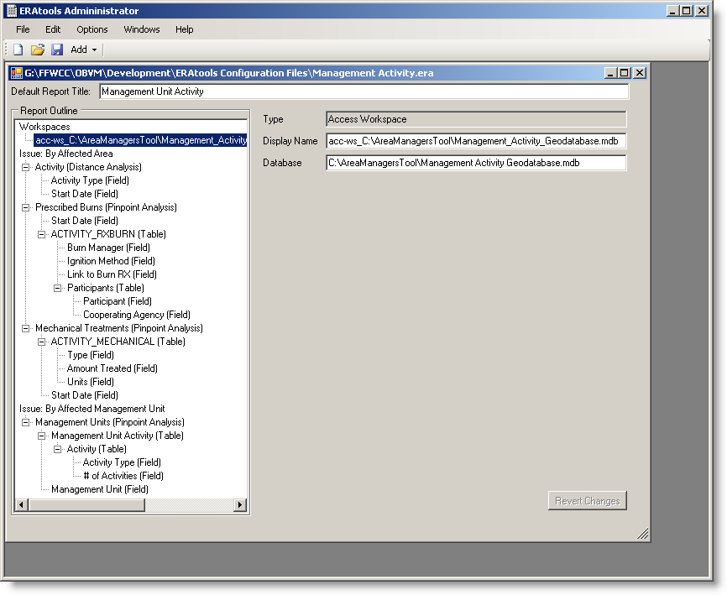
Figure 2-1: ERAtools Administrator Main Screen
The main menu provides options for creating, opening, saving and validating files, copying and pasting report elements, changing options, organizing windows and accessing help.

Creating a New Analysis Definition File
To begin creating an analysis definition file, select New from the File menu (Figure 2-2), or click the New button
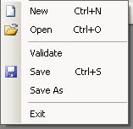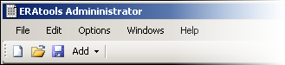
Figure 2-2: File Menu and Toolbar
A new blank form will appear (Figure 2-3).
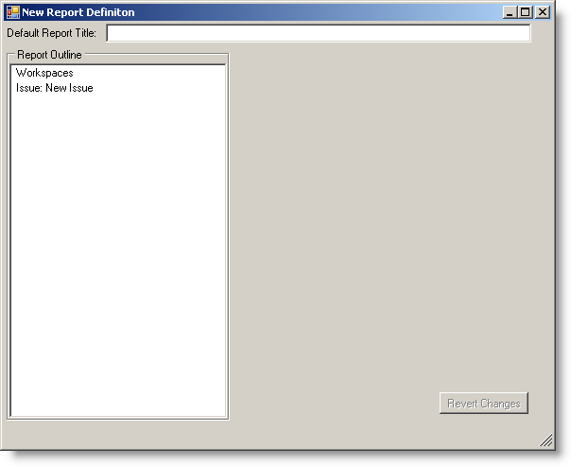
Figure 2-3: Blank Analysis Definition File

Editing an Existing Analysis Definition File
To edit an existing file, select Open from the File menu, or click the Open button on the toolbar.

Saving an Analysis Definition File
To save the current file, click the Save button, or select Save (or Save As) from the File menu. When you select Save As, the original file is unchanged, and the changes you have made are saved to the new file.

Menu Items
You can copy, cut, paste and delete elements by choosing these options from the Edit menu. You can configure the ERAtools administrator to prompt you before deleting report elements by checking the Confirm Delete menu item under the Options menu. The Windows menu provides options for organizing open windows within the application, and the Help menu provides access to a PDF version of this document, along with access to an “About” dialog to provide more information on the current version of the application.
There is also an Add menu shown on the toolbar, which contains varying options for creating new report elements. Depending on which type of report element is currently selected, different options will appear. For example, the New Field option is enabled only if a layer or table element is selected.

Analysis Definition File Elements
Analysis definition files are made up of a series of one or more Issues (Section 3.1), which in turn are made up of one or more Analyses (Section 3.2), which in turn may contain Fields (Section 3.2.4) and Tables (Section 3.3). Data sources for analyses and tables are specified in Workspaces (Section 3.4). These items are displayed

Issues
An Issue is a logical grouping of analyses under a single header. An example of an issue could be “Natural Resources” or “2007 OBVM Monitoring Points Outside DFCs”. In the below example, the Issue is “Activities by Type”.
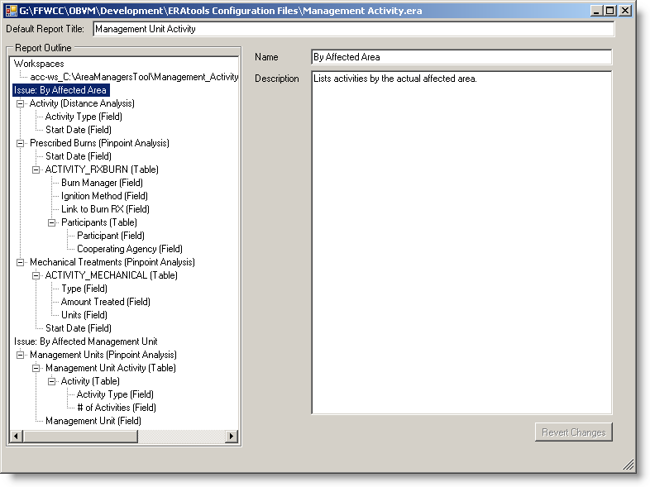
Figure 3-4: Issue Screen

Adding Issues
Each Issue has a name and an optional description.
Name the Issue:
- Highlight the issue and the Name and Description fields will appear.
- Give the issue a name by entering it in the Name field
- Describe the purpose and analysis content of the issue if desired
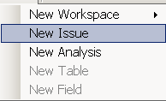

Adding Additional Issues
To add additional issues to the analysis,

- Click the down arrow on the Add down arrow and select New Issue.
- Highlight New Issue in the Name field and give the Issue a Name.
- Describe the purpose and analysis content of the issue if desired.
- Proceed with adding New Analyses to the issue.

Spatial Analyses
The next step in defining an analysis definition file is to add analyses to your issues. An analysis represents a layer to be analyzed. The analysis feature (the point, line, or polygon and associated buffer that the end user specifies) is intersected with the layer, and information related to the layer is returned in the report. To create an analysis, select an issue in the report outline and select New Analysis from the Add menu, or right-click on an issue and select New Analysis from the pop-up menu.
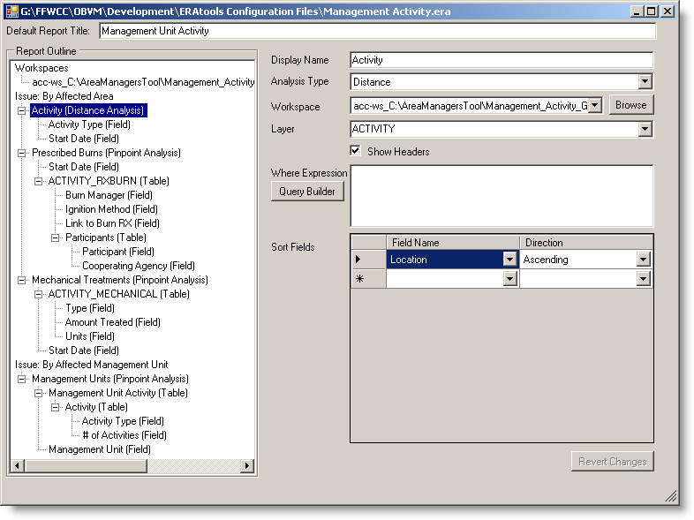
Figure 3-5: Editing Analysis Layers
To set up an analysis, you must enter a display name, select an analysis type, and specify the source of the data. You can have options for displaying column headers, data summarization functions, specifying a where expression and specifying how data should be sorted. These options are described in the following sections.

Analysis Types
Several types of Analyses are available, as described below. In the descriptions, the following terms apply:
Resource Feature: The data layer being analyzed, as specified by the Layer ID property of an analysis.
Analysis Feature: The geographic feature digitized or selected by the ERAtools user and used as the basis for the analysis.
Buffer: Also known as the analysis area—represents the polygon surrounding the analysis feature, the size of which is based on the buffer distance selected by the ERAtools user.

Pinpoint Analysis
The Pinpoint analysis lists specified attributes of all resource features that intersect the analysis feature. The buffer is not used.

Generic Resource Analysis
The Generic Resource analysis lists specified attributes of resource features that intersect the analysis feature. If a buffer is used during the analysis run, attributes for resource features intersecting the buffer will be listed separately.
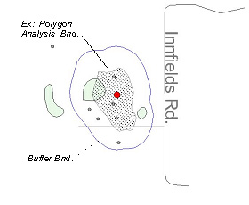
Figure 3-6: Generic Resource Analysis

Weighted Average
The Weighted Average analysis weights specified numeric attributes of the intersecting resource features based on the proportion of the intersecting area (the overlap of the analysis feature or buffer area and the resource feature) within the entire analysis area. This analysis type is primarily designed for analysis of polygon resource features within a polygon analysis feature, or buffered line or polygon analysis feature. Depending on the feature type (point, line or polygon) of the resource feature, the analysis behaves differently:
- Point or Linear Resource Features: reports the sum of the specified numeric attributes of resource features within the analysis area.
- Polygon Resource Features: reports the sum of specified numeric attributes values of resource features within the analysis area, and weights the values for each resource feature proportionally to the overall size of either the analysis feature or resource feature (both options are provided).
The proportional-to-analysis-feature-size option is useful for datasets where the data being analyzed represents some kind of index that is independent of the overall size of the resource feature. Examples include the population density in a given area, or the land use intensity index for a given area. This method weights the individual values by the proportion of the analysis feature comprised of the intersecting resource feature. The formula for this method is shown below:
Σ (
Overlap Area * Value )
Total Overlap Area
The proportional-to-resource feature-size option is useful for datasets where the data being analyzed represents a total count of things contained by the resource feature, thus making the overall size of the resource feature relevant to the calculation. Examples include the total population of a given area, or a count of wildlife observations within a wildlife management area. Although it’s referred to as a weighted average, in this case it may be more accurate to think of the analysis as a weighted sum. It is included as an option within the weighted average analysis so that both methods can be employed on a single layer being analyzed. The formula for this method is shown below:
Σ (
* Value )
Overlap Area
Resource Area

Both options take into account no-data portions of the analysis feature. The portions of the analysis feature that do not intersects any resource features, or which intersect resource features with null values for the field being analyzed, are excluded from the analysis.
The example shown below in Figure 3-7 shows several census tracts, labeled by tract ID. The data for the tracts intersecting the analysis feature is shown in the table below the graphic.
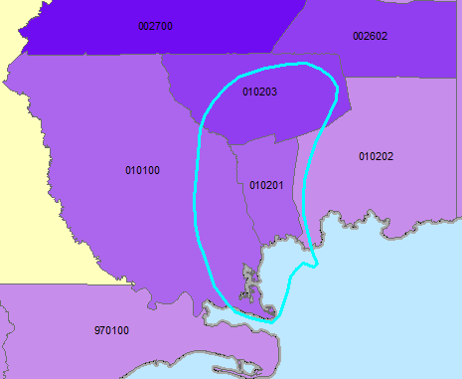
Figure 3-7: Weighted Average Analysis

Tract | Resource Feature Area | Overlap Area | Population
Tract | Resource Feature Area | Overlap Area | Total | Density
010100 | 314.26 | 61.01 | 5308 | 16.9
010201 | 40.36 | 40.36 | 5642 | 139.7
010202 | 160.75 | 10.00 | 4253 | 26.5
010203 | 102.03 | 59.45 | 7660 | 75.1
No Data |  | 23.38 | N/D | N/D
Total/Avg | 194.20 | 194.20 | 22863 | 64.55

A weighted average analysis performed on this data, using the cyan-highlighted analysis feature, will result in a weighted average population density (using the indexed, proportional-to-analysis-feature option) of 66.7 persons per square mile, calculated are as follows:
(61.01 * 16.9 ) + (40.36 * 139.7) + (10.00 * 26.5) + (59.45 * 75.1)
(61.01 + 40.36 + 10 + 59.45)
= 66.7
This is slightly different from the non-weighted average of the density field (64.55), because it takes into account the relative proportions of the census tracts within the analysis area.
A weighted average analysis of the total population (using the indexed, proportional-to-resource feature option) is as follows:
10
160.75

61.06
314.26

* 5308 +

40.36
40.366

* 5642 +

59.45
102.03

* 4253 +

* 7660 = 11,400

The result of 11,400 persons is considerably smaller than a simple sum of the total population, as it takes into account that only portions of some of the intersecting census tracts are within the analysis area.

Feature Comparison
The Feature Comparison analysis summarizes the unique values found in features in the resource layer that intersect the analysis area, and reports the amount of those features as follows, based on the analysis and resource layer geometry types:
- For point and linear analysis features, this analysis reports attributes from the resource and:
  - For point resources, a count of features within the analysis buffer area
  - For linear resources, the total linear feet within the analysis buffer area
  - For polygon resources, the total acres within the analysis buffer area.
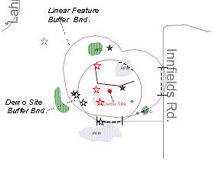
Figure 3-8: Feature Comparison Analysis (Point or Linear Analysis Features)
- For polygon analysis features, this analysis reports attributes from the resource and:
  - For point resources, a count of features within the analysis area and a count of features within the buffer area
  - For linear resources, the total linear feet within the analysis area and the total linear feet within the buffer area
  - For polygon resources, the total acres within the analysis area and the total acres within the buffer area
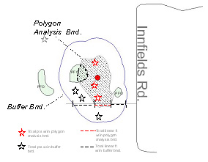
Figure 3-9: Feature Comparison Analysis (Polygon Analysis Features)

Distance
The Distance analysis lists resource features that intersect the user-specified analysis feature and buffer, and reports the distance of the resource feature from the analysis feature. This analysis will not run correctly if the user does not enter a buffer distance greater than zero. Based on the geometry types of the analysis feature and resource features, this analysis reports as follows:
- Point Analysis Features
  - Point Resource Feature: from the point analysis feature, reports the distance to point features within the analysis area.
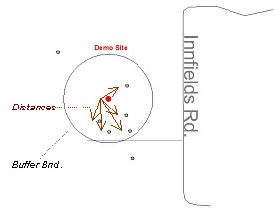
Figure 3-10: Distance Analysis: Point-to-Point
  - Linear Resource Features: from the point analysis feature, reports the distance to the closest point of linear resources features within the analysis area.
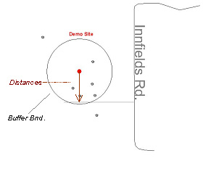
Figure 3-11: Distance Analysis: Point to Line
  - Polygon Resource Features: from the point analysis feature, reports the distance to the closest point on the perimeter of polygon resource features within the analysis area.
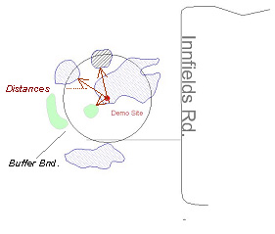
Figure 3-12: Distance Analysis: Point-to-Polygon
- Linear Analysis Features
  - Point Resource Features: from the closest point on the linear analysis feature, reports the distance to point resource features within the analysis area.
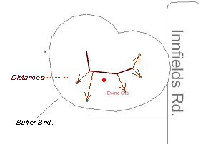
Figure 3-13: Distance Analysis: Line to Point
  - Line Resource Features: from the closest point on the line analysis feature, reports the distance to the closest point on line resource features within the analysis area.
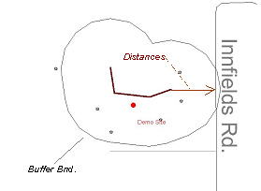
Figure 3-14: Distance Analysis: Line to Line
  - Polygon Resource Features: from the closest point on the line analysis feature, reports the distance to the closest point on the perimeter of polygon resource features within the analysis area.
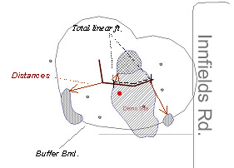
Figure 3-15: Distance Analysis: Line to Polygon
- Polygon Analysis Features
  - Point Resource Features Intersecting the Analysis Feature: reports the distance from point features within the polygon analysis feature to the closest point on the perimeter of the polygon analysis feature.
  - Point Resource Features Intersecting the Buffer Area: reports the distance from point features outside the polygon analysis feature to the closest point on the perimeter of the polygon analysis feature.

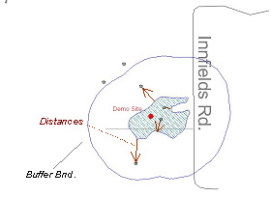
Figure 3-16: Distance Analysis: Polygon to Point
  - Linear Resource Features Intersecting the Analysis Feature: reports the closest distance from a point on line features within the polygon analysis feature to the closest point on the perimeter of the polygon analysis feature.
  - Linear Resource Features Intersecting the Buffer Area: reports the closest distance from a point on line features outside the polygon analysis feature to the closest point on the perimeter of the polygon analysis feature.
  - Polygon Resource Features Intersecting the Analysis Feature: if resource feature is entirely within the analysis feature, and their edges do not intersect, reports the shortest distance from a point on the edge of the resource feature to a point on the edge of the analysis feature.
  - Polygon Resource Features Intersecting the Buffer Area: reports the closest distance from a point on polygon features outside the polygon analysis feature to the closest point on the perimeter of the polygon analysis feature.
In all cases, if a resource feature intersects (overlaps) the edge of an analysis feature (such as when a linear resource intersects a linear analysis feature, or when a polygon resource intersects the edge of a polygon analysis feature), the analysis reports “Intersects analysis feature”

Distance and Direction
The Distance and Direction analysis performs the same distance analysis as described above, but also includes a field that gives the direction from the analysis feature to the resource feature. The direction given is between the two closest points between the analysis feature and resource feature.

Comparison Resource
The Comparison Resource analysis summarizes a pair of analysis layers, a “parent” layer (the layer specified in the analysis setup screen), and a “child” layer (set up as a sub-table, as if it were a one-to-many relationship). The parent layer must contain polygon features. The child layer can contain point, line, or polygon features. See Section 3.3.1 for information on how to set up this analysis. Depending on the child layer feature type, this analysis reports as follows:
- Point analysis features: Lists the count of features from the child analysis layer within the analysis area, categorized by whether they intersect polygon features of the parent layer.
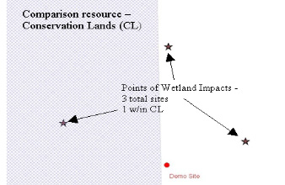
Figure 3-17: Comparison Resource Analysis: Point Features
- Liner analysis features: Lists the total length of linear features from the child analysis layer within the analysis area, categorized by whether they intersect polygon features of the parent layer.

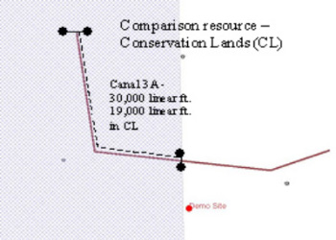
Figure 3-18: Comparison Resource Analysis: Linear Features
- Polygon analysis features: Lists the total area of polygon features from the child analysis layer within the analysis area, categorized by whether they intersect polygon features of the parent layer.
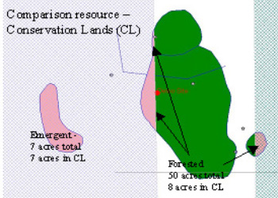
Figure 3-19: Comparison Resource Analysis: Polygon Features

Specifying Data Source
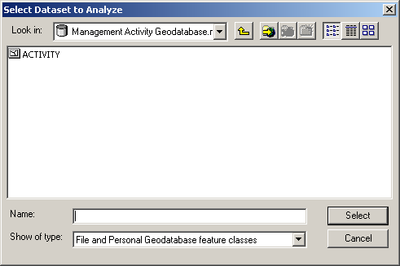
An analysis layer comes from one of the configured workspaces described below. You browse to the layer’s source or select an existing Workspace from the drop-down list. Once a workspace is selected, you can type the name of the layer or select the layer name from the Layer ID drop-down list.
To browse to the data, click the Browse button. The standard ArcMap “Add Data” dialog for loading layers in a map is displayed. You can refer to ArcMap documentation under the “Add Data button” index heading for more detailed information on using this dialog.

Figure 3-20: Browsing for Data

Specifying a Definition Query
The layer can be filtered by specifying a “where” expression (also known as a definition query). The syntax for the definition query is dependent on the underlying type of data (shapefiles use a different syntax from SDE data, which in turn can vary by the database management platform). You can either enter the query directly, or use the Build Query function to guide you in defining a query.
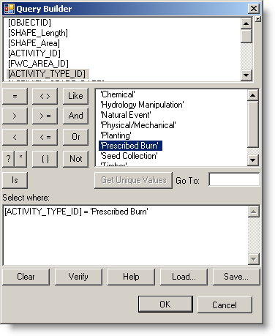
Figure 3-21: Query Builder
The following description of how to use the query builder is taken from ArcGIS help. To get more help, including a quick reference guide to the SQL keyboards and operators, search for the topic called 'SQL reference' in the ArcGIS Desktop Help by typing that name into the Search tab in the Desktop Help.
The query builder dialog lets you select features in a layer or records in a table by building a query. To create an expression, double-click the field you want to use, click an operator, then double-click the value. You can also type directly into the query.
For example, this query will select all “Prescribed Burn” land management activities from a personal geodatabase:
[ACTIVITY_TYPE_ID] = 'Prescribed Burn'
When you use this dialog, you are actually creating a SQL query. The syntax of the query differs depending on the data source you are querying. The expression is sent to the data source and interpreted there rather than being parsed in the dialog, so expressions are in the native format for the database at which they are aimed.

Field names
The Field list in this dialog automatically lists fields with the appropriate delimiters for the type of data you are querying:
- If you are querying data in a file geodatabase, shapefile, dBase table, coverage, INFO table, then field names are enclosed in double quotes:
"FIELD"
- If you are querying data in a personal geodatabase then field names are enclosed in square brackets:
[FIELD]
- If you are querying data in an ArcSDE geodatabase (i.e., data accessed via a database connection to an ArcSDE Enterprise geodatabase, or data accessed from a database server running ArcSDE Personal Edition or Workgroup Edition), then are not enclosed:
AREA

Strings
Strings must always be enclosed within single quotes. For example:
"STATE_NAME" = 'California'
Strings in expressions are case sensitive, except when you are querying personal geodatabase feature classes and tables. To make a case insensitive search in other data formats, you can use a SQL function to convert all values to the same case. For file-based data sources, use either the UPPER or LOWER function.
For example, the following expression will select customers whose last name is stored as either Jones or JONES:
UPPER("LAST_NAME") = 'JONES'
Other data sources have similar functions. Personal geodatabases, for example, have functions named UCASE and LCASE that perform the same function.
Use the LIKE operator (instead of the = operator) to build a partial string search. For example, this expression would select Mississippi and Missouri among the USA state names:
"STATE_NAME" LIKE 'Miss%'
You can use greater than (>), less than (<), greater than or equal (>=), less than or equal (<=) and BETWEEN operators to select string values based on sorting order. For example, this expression will select all the cities in a layer with names starting with the letters M to Z:
"CITY_NAME" >= 'M'
The not equal (<>) operator can also be used when querying strings.

Wildcard Characters
A wildcard character is a special symbol that stands for one or more characters.
For any file-based data, '%' means that anything is acceptable in its place: one character, a hundred characters, or no character. Alternatively, if you want to search with a wildcard that represents one character, use “_”.
For example, this expression would select any name starting with the letters Kath, such as Kathy, Katherine, and Katherine Smith:
"NAME" LIKE 'Kath%'
But this expression would find Catherine Smith and Katherine Smith:
"OWNER_NAME" LIKE '_atherine smith'
The wildcards you use to query personal geodatabases are “*” for any number of characters and “?” for one character.
Wildcard characters appear as buttons on the query dialog. You can click the button to enter the wildcard into the expression you’re building. Only the wildcard characters that are appropriate to the data source of the layer or table you are querying are displayed.
If you use a wildcard character in a string with the = operator, the character is treated as part of the string, not as a wildcard.

The NULL keyword
Null values are supported in fields for geodatabases and for date fields in shapefiles/dBASE tables. If you select a field of a type that supports null values, and if that field contains any null values in the records displayed by the Unique Values list, you'll see a NULL keyword at the top of the Unique Values list. You can double-click the NULL keyword to add it into your expression, where you can use the IS operator to query the field to select all its null values:
"POPULATION96" IS NULL
or IS NOT to select all its values that aren't null:
"POPULATION96" IS NOT NULL
The NULL keyword is always preceded by IS or IS NOT.

Querying Numbers
You can query numbers using the equal (=), not equal (<>), greater than (>), less than (<), greater than or equal (>=), and less than or equal (<=) operators.
"POPULATION96" >= 5000
The point is always used as the decimal delimiter regardless of your regional settings. The comma cannot be used as a decimal or thousands delimiter in a query.

Calculations
Calculations can be included in queries using these arithmetic operators: + - * /
Calculations can be between fields and numbers.
For example:
"AREA" >= "PERIMETER" * 100
Calculations can also be performed between fields.
For example, to find the countries with a population density of less than or equal to 25 people per square mile, you could use this expression:
"POP1990" / "AREA" <= 25
Note: calculations between fields in a shapefile (or a dBASE table) are not supported.

Operator Precedence
Expressions evaluate according to standard operator precedence rules. For example, the part of an expression enclosed in parentheses is evaluated before the part that isn’t enclosed.
This example:
HOUSEHOLDS > MALES * POP90_SQMI + AREA
evaluates differently from:
HOUSEHOLDS > MALES * (POP90_SQMI + AREA)
You can either click to add parentheses and then enter the expression you want to enclose, or highlight the existing expression that you want to enclose and then press the Parentheses button to enclose it.

Combining Expressions
Expressions can be combined together with the AND and OR operators.
AREA > 1500 AND GARAGE > 3
When you use the OR operator, at least one expression of the two expressions separated by the OR operator must be true for the record to be selected.
RAINFALL < 20 OR SLOPE > 35
Use the NOT operator at the beginning of an expression to find features or records that don't match the specified expression. NOT expressions can be combined with AND and OR.
SUB_REGION = 'New England' AND NOT STATE_NAME = 'Maine'

Querying Dates
The syntax required for querying dates depends on the data type. The query builder will automatically write the proper syntax for you when you double-click a date value in the Unique Values list. See the SQL reference mentioned above for more about querying dates.

Column Headers
The “Show Headers” checkbox allows you to specify whether column headers should appear in the output.

Grouping and Summarizing Data
Data grouping and summarization functions can be specified for many analysis types that return individual rows without performing some kind of spatial summarization, including the generic resource, pinpoint and distance analyses. To enable these functions, check the “Enable Data Grouping/Summarization Functions” checkbox shown on the analysis screen. The individual fields that are included for the analysis will display options for grouping or summarizing the data (see Section 3.2.7).

Sorting Data
The data can be sorted by any of the fields included in the output (see Section 3.2.7). Select the fields and sort direction from the Field Name drop-down shown in the Sort Fields table (Figure 3-22). Only those fields that are included in the output can be selected for sorting. The distance analysis (Section 3.2.1.5) also includes options to sort by distance and location (a field which indicates whether a selected feature intersects, or is within the buffer of, the analysis feature).
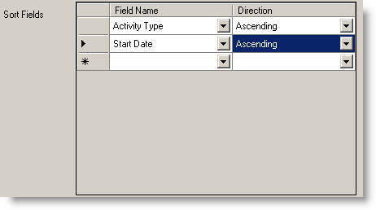
Figure 3-22: Sorting Data

Specifying Fields to Display
To add a field to an analysis, select the analysis from the outline and select New Field from the Add menu, or right-click on an analysis in the contents pane and select New Field from the pop-up menu. If you have established a link to a valid layer, the fields will be filled in the field name drop-down list. If not, you will have to type in the field name. You must enter a display name, which will be used as a header for the field in the final report if the “Show Headers” option is enabled (Section 3.2.4). Note: even if the “Show Headers” option is not enabled, you must enter something in the Display Name field.
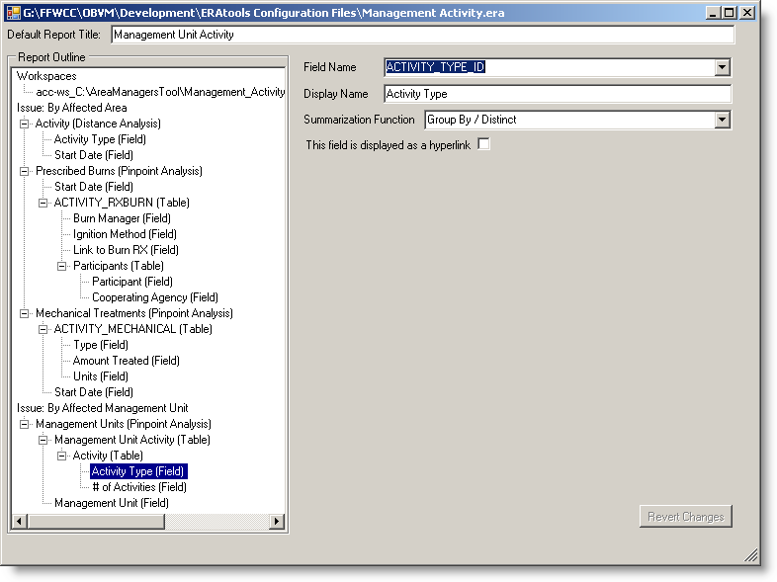
Figure 3-23: Editing Fields

Summarization Options
When the Enable Data Grouping/Summarization Options checkbox is checked on the analysis or table screen, fields associated with layer or table will display the Summarization Function drop-down list, which provides the following functions:
- Group By/Distinct: the unique combination of values in all fields set to this option will be reported. Other data are summarized based on the association with distinct Group By values.
- Sum: the sum of all numeric values found in the specified field
- Average: the average of all non-null, numeric values found in the specified field
- Minimum: the alphanumeric minimum value found in the specified field
- Maximum: the alphanumeric maximum value found in the specified field
- Count: the count of non-null values found in the specified field

Weighted Average Analysis Options
For weighted average analyses, the field screen shows an option to choose the weighted average type. Refer to the discussion on weighted average types in Section 3.2.1.3 for details on the two options provided.
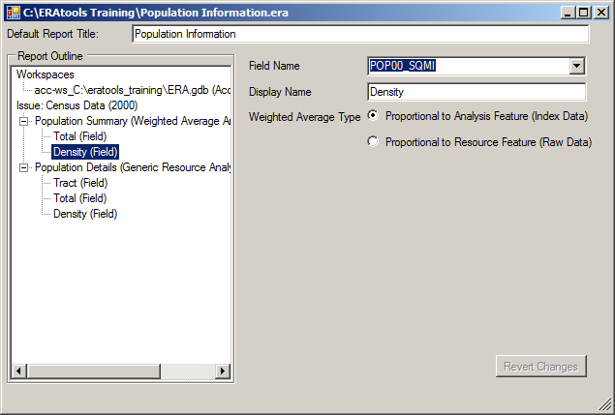
Figure 3-24: Weighted Average Type

Hyperlinks
If the “This field is displayed as a hyperlink” checkbox is checked, additional properties for the field are displayed which direct ERAtools in how to construct a hyperlink URL from the data stored in the field (Figure 3-25).
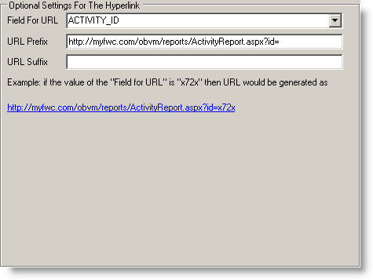
Figure 3-25: Hyperlink Options
The “Field for URL” drop-down allows you to specify another field which will provide the data to use in creating the actual URL (the Field Name drop-down specifies the field whose contents will be displayed). If this is left blank, the field used for display will also be used for the URL. The URL Prefix and Suffix fields allow you to enter the text that will precede and follow the data returned from the “Field for URL” field to complete the full URL. For your reference, an example URL is generated and displayed on the form.

Related Tables
The analysis types that return individual rows (not analyses that summarize the data, such as the comparison resource analysis) can be associated by parent/child keys or by spatial relation with related child tables or layers, by either a nested, “one-to-one-or-more” relationship, with records appearing in a nested table under each parent record returned by the analysis, or an in-line, “one-or-many-to-one” fashion, with data from the related table appearing on the same line as each record returned by the analysis. Figure 3-26 shows an example output from both types of related tables. In the example, data from a layer that represents management unit activity areas is queried, and the Start Date is included in the output. Data from the related prescribed burn table contains more detailed information on the prescribed burn, and is displayed on the same line as the data from the layer. Another related table stores information on participants within prescribed burns. The data for this record is shown in a table nested below the “parent” record from the layer.
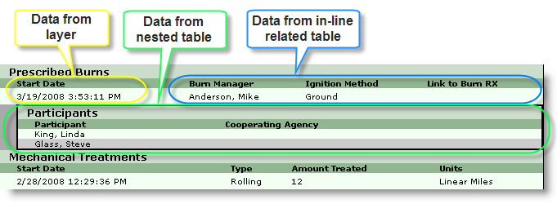
Figure 3-26: Related Tables
To add a related table, select a layer and select New Table from the Add menu, or right-click on a layer and choose New Table from the pop-up menu. You must specify the workspace, layer ID (table name), an optional “where” expression, and information on how to join the the data. If the related table is a spatial dataset, you can choose to do a spatial join (data are selected from the feature class based on simple intersection with features from the parent layer). If it is not a spatial dataset, or you wish to do an attribute join, you must specify at least one pair of parent/child keys. The parent key represents a unique identifier in the parent layer, and the child key represents a column that stores the “foreign key” that relates records in the table to the parent layer. To indicate that the data should appear in-line with the parent record, check the “Display In-Line with Parent” checkbox. If the data is to be shown in a nested table, uncheck this checkbox. This will enable the “Enable Data Summarization Functions” and “Show Headers” checkbox. Refer to Sections 3.2.5 and 3.2.4 for more information on these options. As you can with the layer, you can specify sorting options (see Section 3.2.6).
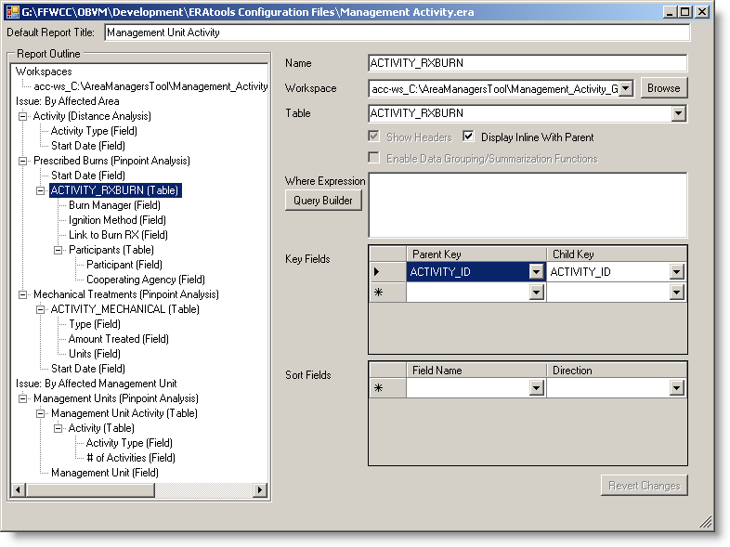
Figure 3-27: Editing Tables
Tables can also have child tables, resulting in as many sub-queries of sub-queries your data analysis requires.

Related Tables in Comparison Resource Analysis
For the comparison resource analysis, you specify the second layer to be analyzed as a related table. The second layer must be a spatial layer, and it is not necessary to provide the parent/child keys, as the relationship is determined spatially when the report is run. The parent layer must contain polygons. The child layer may contain points, lines, or polygons.

Workspaces
Workspaces represent the containing folders and database connections that store the layers included in the analysis definition file. Under normal usage, the workspaces are automatically managed by the application. When you browse to a layer, the system checks to see if a link to the workspace has already been defined in the analysis definition file, and if not, adds the connection information as appropriate to the type of workspace. This is the recommended way to manage workspaces in the ERAtools Administrator. If you need to manage a workspace (such as to change the password for an SDE workspace or to specify a different folder for a shapefile or personal geodatabase), you can do so by selecting the workspace from the contents pane. All types of workspaces need to be identified by a unique name within the file.

SDE Workspaces
SDE workspaces represent connections to an ArcSDE spatial database engine server. SDE connections require that you enter a server name, a service (usually ESRI_SDE or 5151, depending on how your system is set up), an optional database (required only for SDE running on certain underlying database management systems), a user name, and a password. Note that the password is stored in plain text in the analysis definition file distributed to users.
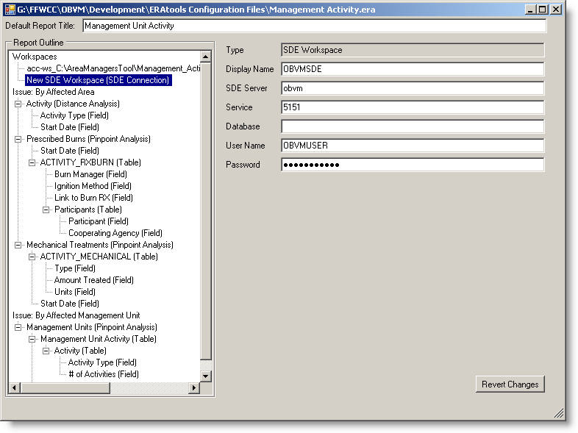
Figure 3-28: SDE Workspace

Shapefile Workspaces
A shapefile workspace is a directory on a local disk or remote file server. Enter the full path to the directory.
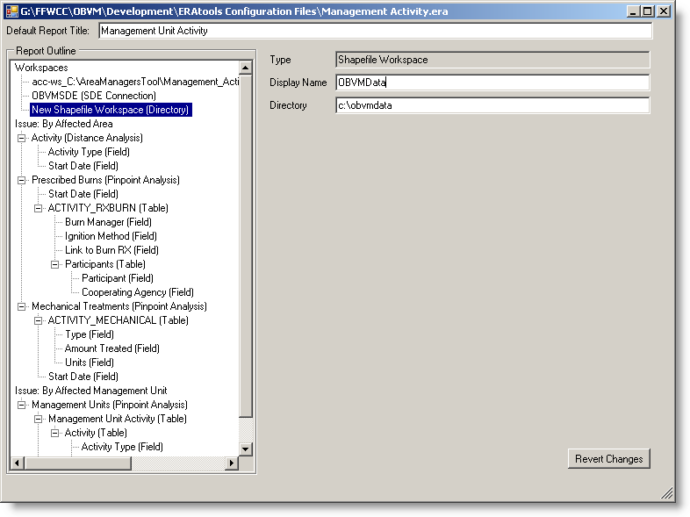
Figure 3-29: Shapefile Workspace

Access Workspaces
An Access workspace is a link to an ESRI personal geodatabase stored within an Access mdb file. Enter the full path to the database (including the database filename).
If you are working with ArcGIS 9.2, it may also refer to a file-based personal geodatabase, but is still referred to as an Access Workspace within ERAtools. Enter the full path to the folder that contains the geodatabase files, including the .gdb extension.
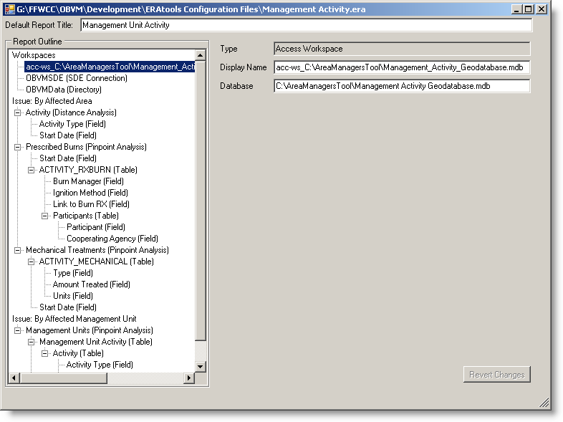
Figure 3-30: Access Workspace

Analysis Definition File Validation
You can validate the analysis definition file to ensure that it will run as intended. To do this, select Validate from the File menu. The system will attempt to connect to each workspace, layer, and table; validate definition queries; and check if the fields referenced in the file exist in the layer or table. It will also ensure that all required fields are entered. Errors are indicated in the outline by text highlighted in red. Select an element from the report outline to see more detailed error messages on the form. Move the mouse cursor over the red-highlighted elements in the outline to see the specific error message. If the error relates to a specific item of the report element, it will appear on the form as a red exclamation point icon. Move your mouse cursor over the icon to see the error message.

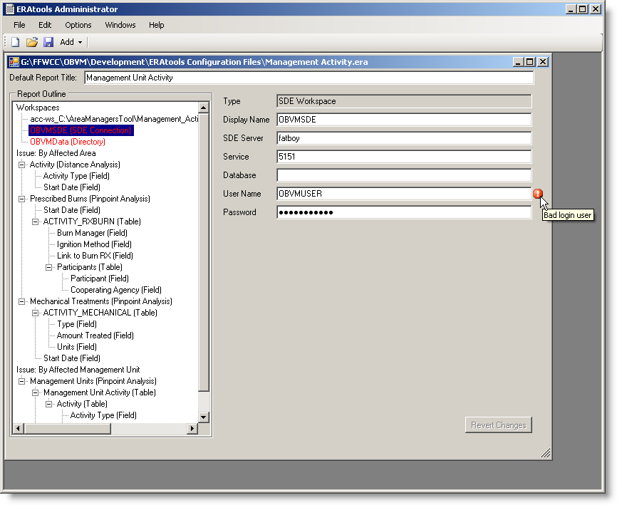
Figure 4-31: Validation Result

